**AP 7th Assignment**

**#DP basic problems**

**Q1. Climbing Stairs**

**Code:**

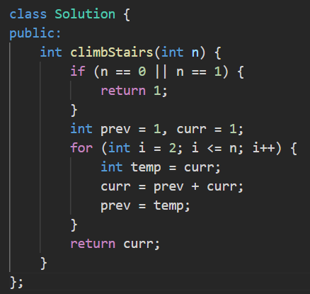

**Output:**

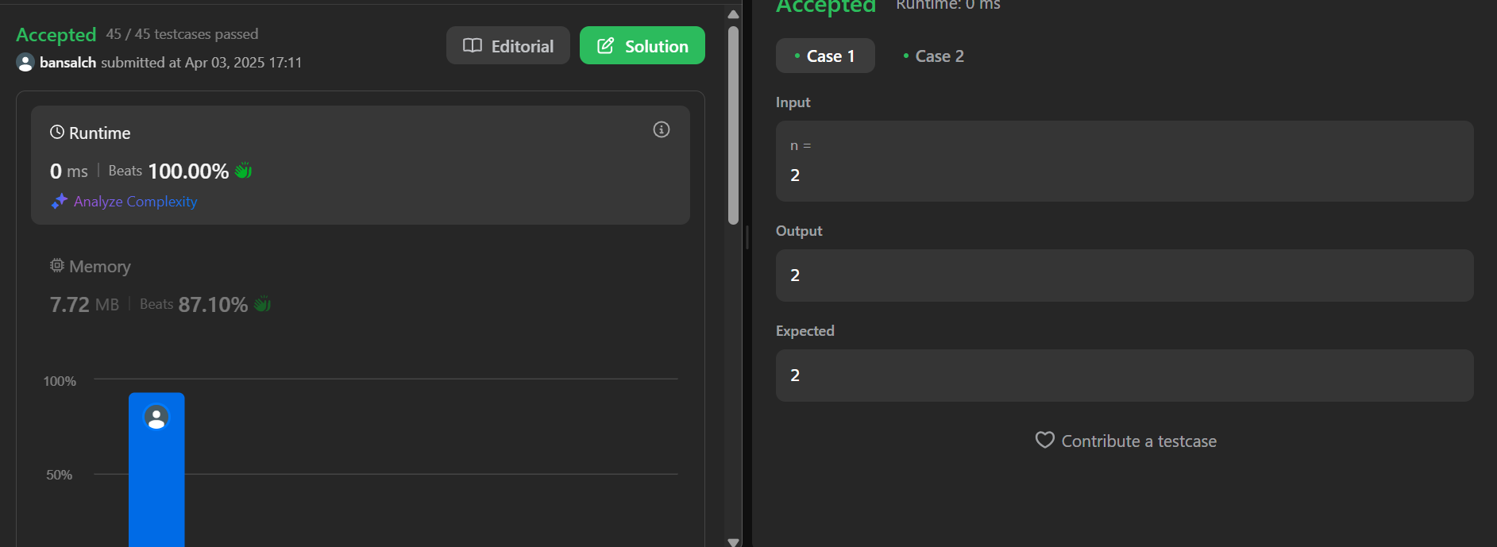

**Q2. Maximum Subarray**

**Code:**

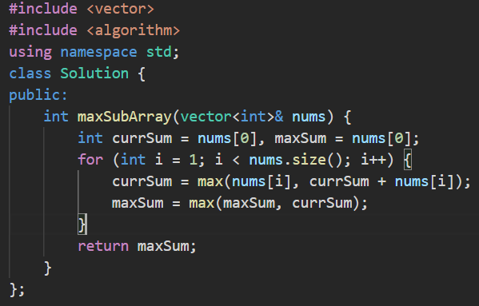

**Output:**

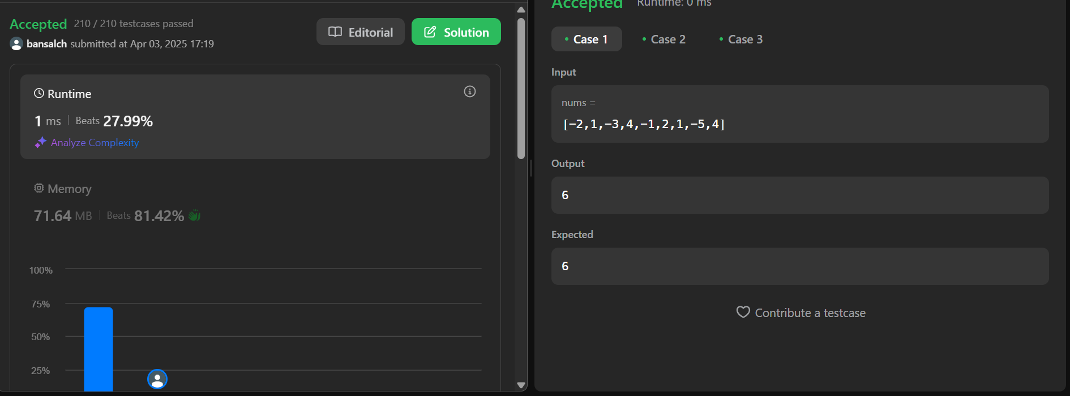

**Q3. House Robber**

**Code:** 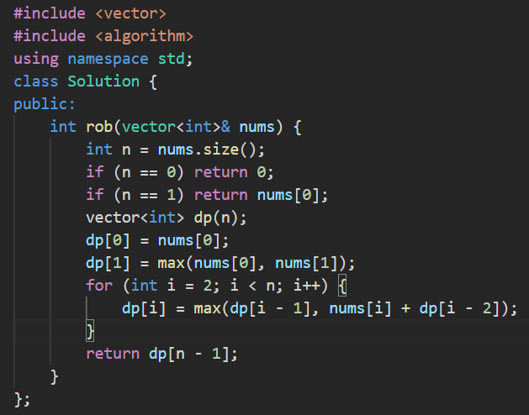

**Output:**

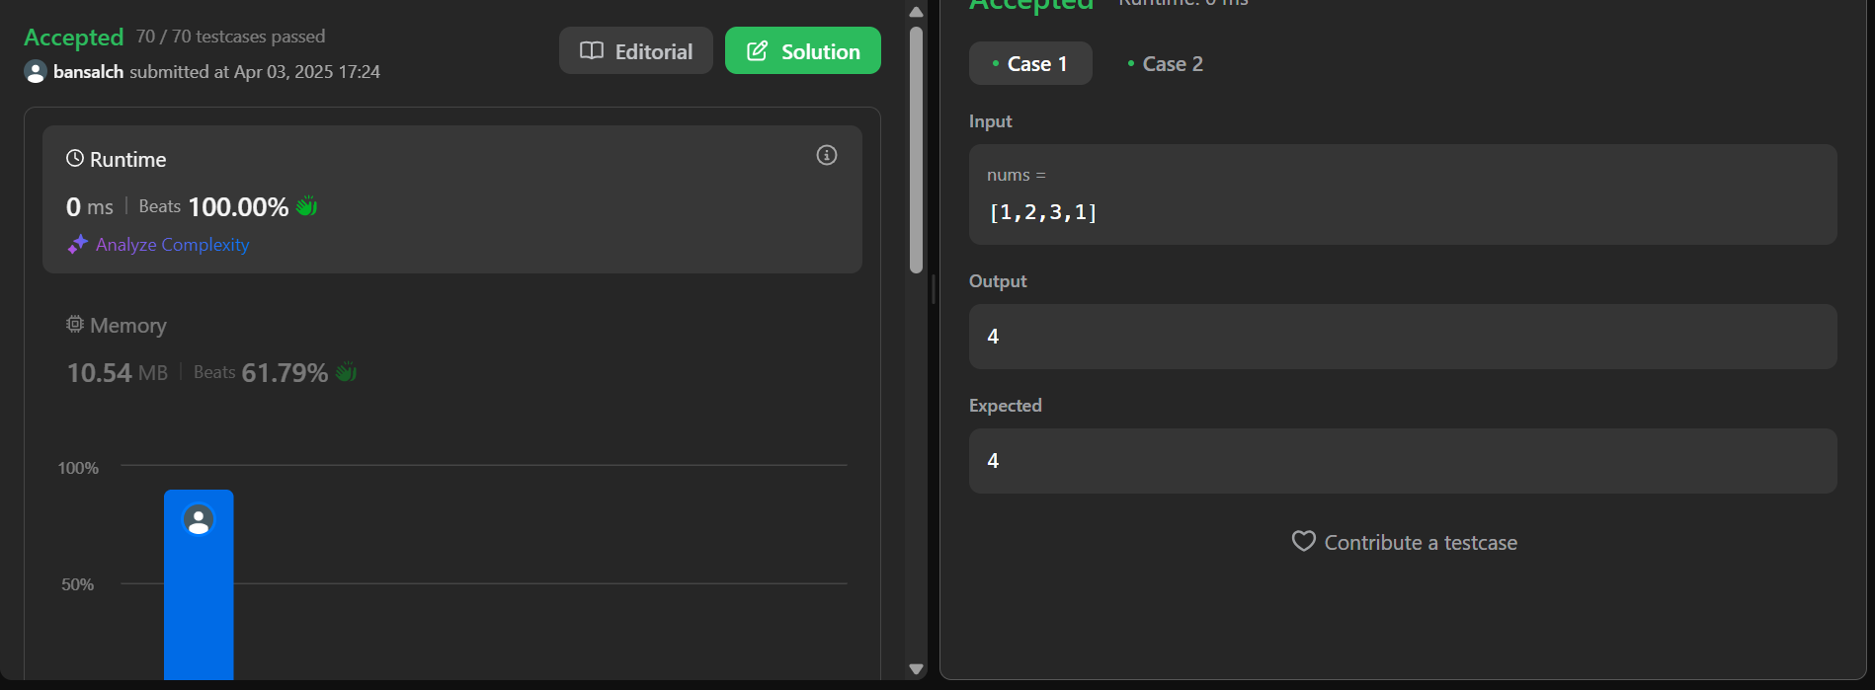

**#Dynamic Programming (Intermediate Problems)**

**Q1. Jump Game**

**Code:**

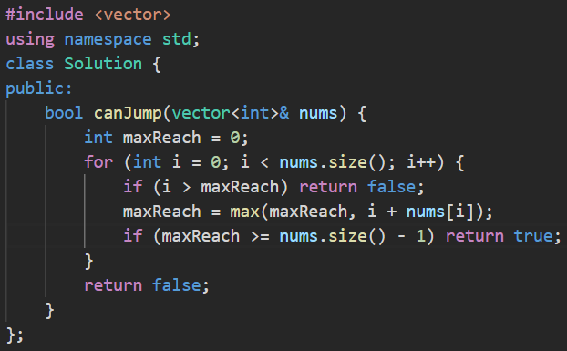

**Output:**

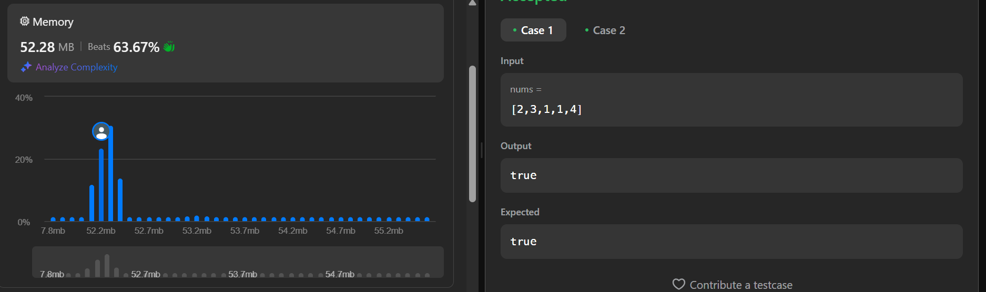

**Q2. Unique Paths**

**Code:**

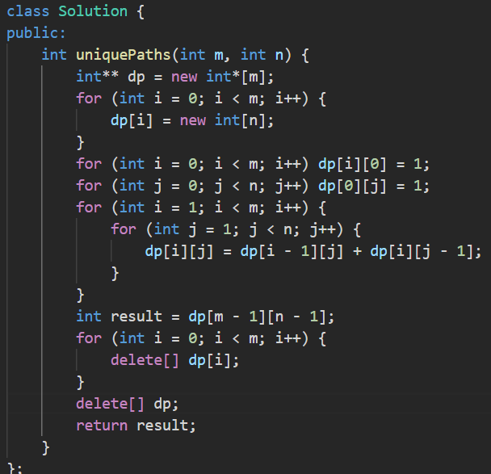

**Output:**

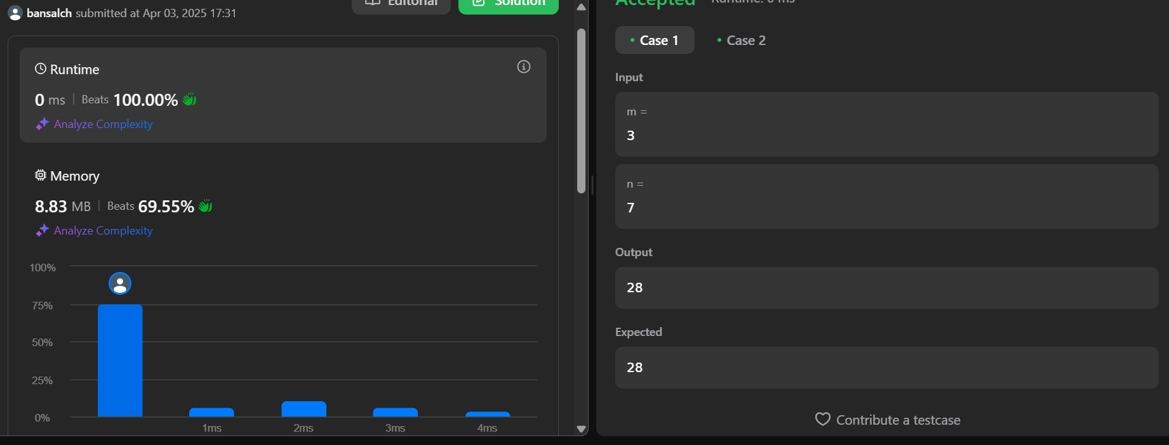

**Q3. Coin Change**

**Code:**

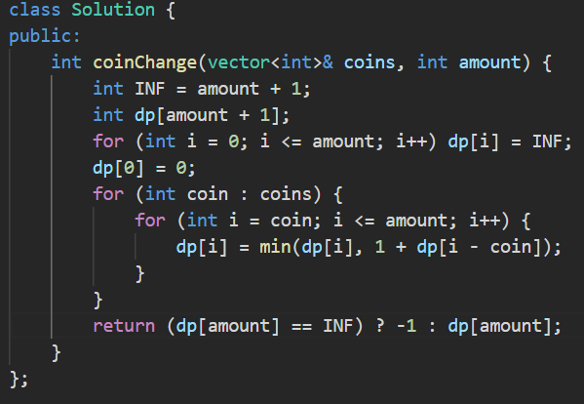

**Output:**

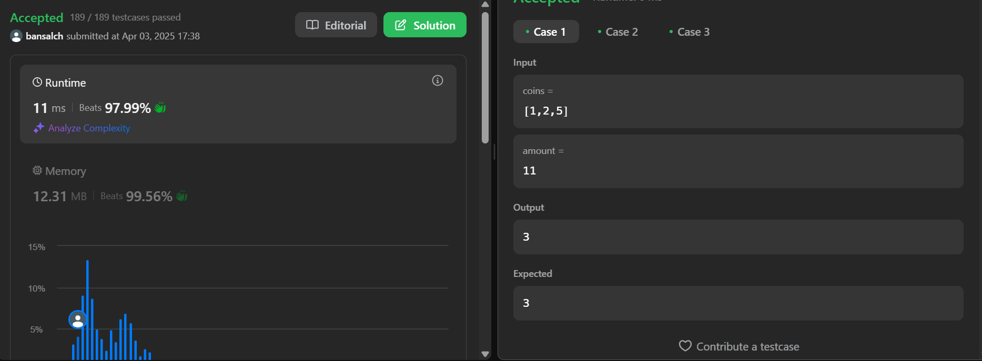

**Q4. Longest Increasing Subsequence**

**Code:** 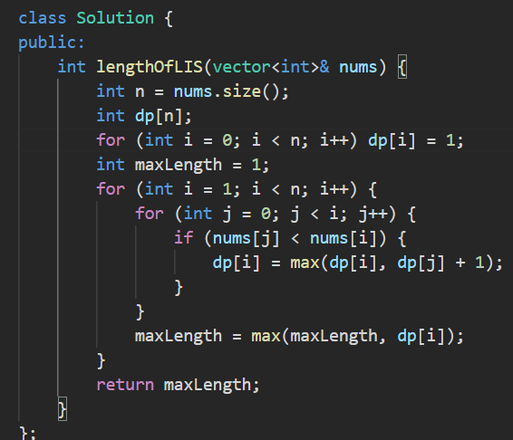

**Output:**

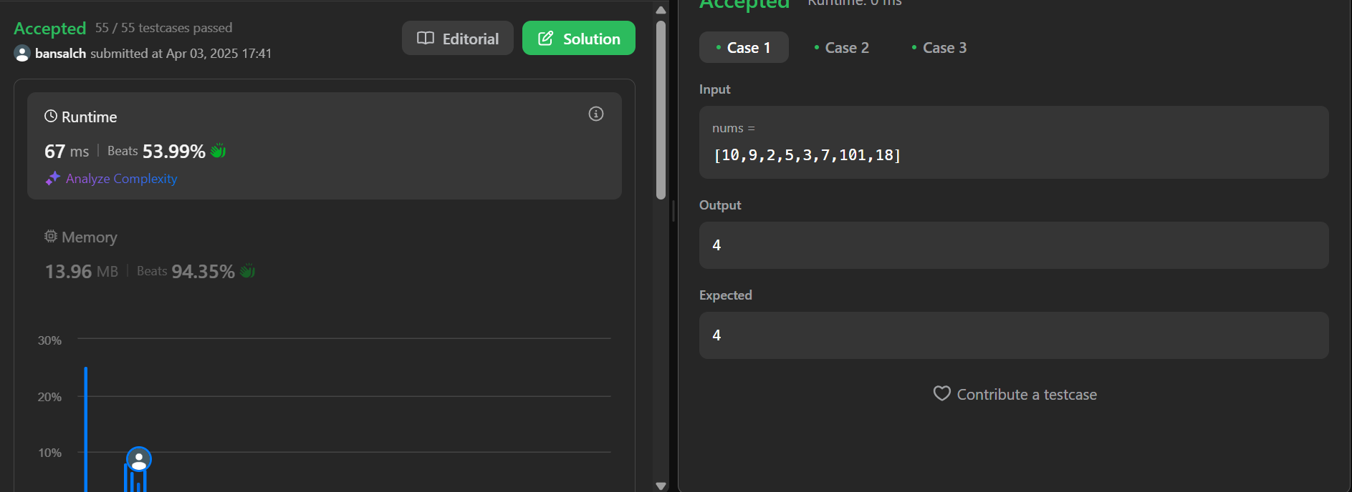

**#Dynamic Programming (Advanced Problems)**

**Q1. Maximum Product Subarray**

**Code:**

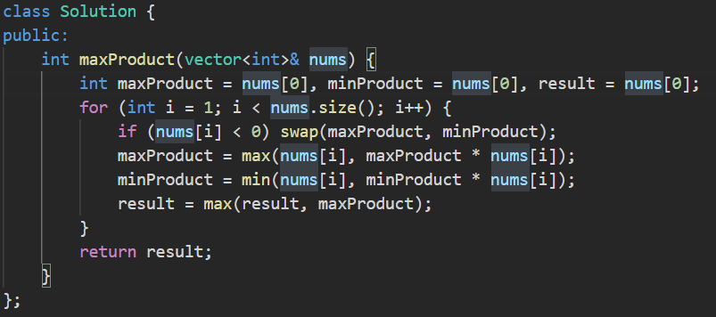

**Output:**

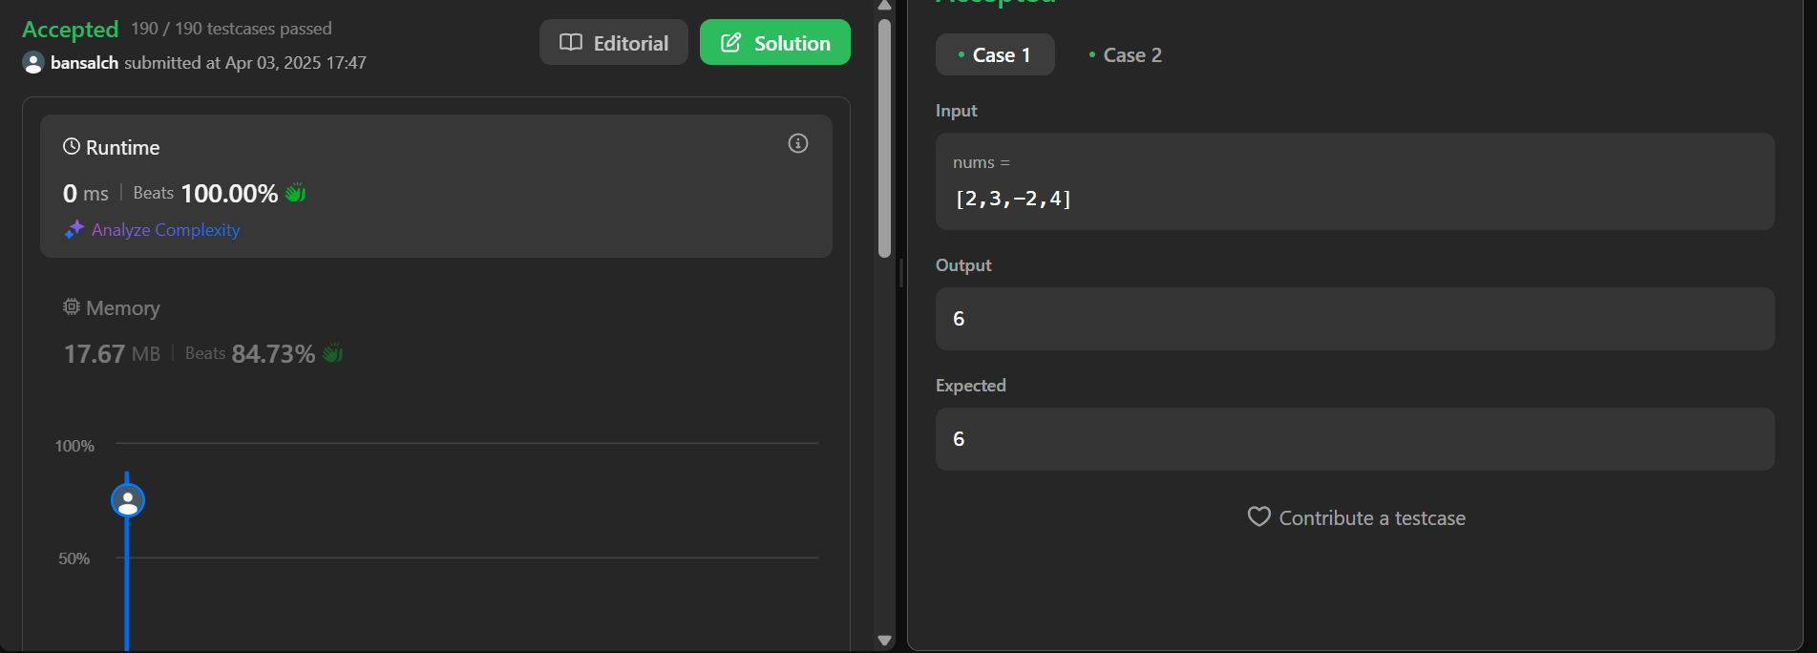

**Q2. Decode Ways**

**Code:**

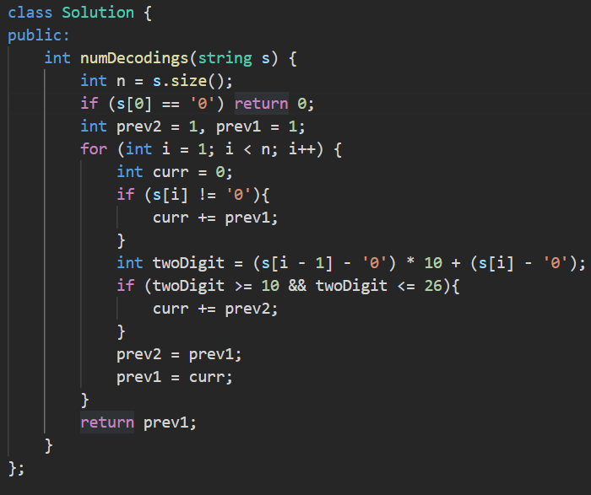

**Output:**

